é

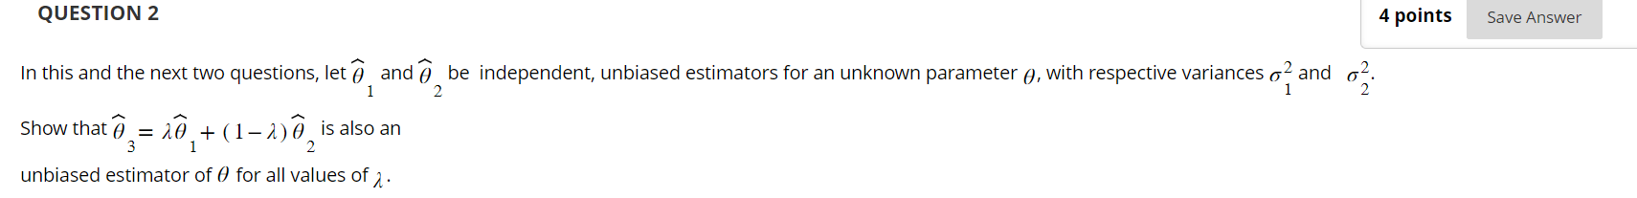

* A close up of text

  Description automatically generated
* 
* A close up of a text

  Description automatically generated
* A close-up of a computer screen

  Description automatically generated
* A close up of a text

  Description automatically generatedA white background with text

  Description automatically generated with medium confidenceA group of colorful lines

  Description automatically generated with medium confidence

